Approach

Existing method. The work most closely related to ours is [1] which introduces the PICOS method utilizing ChatGPT for title and abstract screening in systematic reviews. The PICOS method screens papers based on five critical criteria: population, intervention, control, outcomes, and study design. For each criterion, PICOS prompts ChatGPT to assess the relevance of a given title and abstract to the systematic review. If the title and abstract are considered relevant for a specific criterion, ChatGPT outputs "INCLUDE" for that criterion. Conversely, if they are deemed irrelevant, ChatGPT outputs "EXCLUDE," and if it cannot decide, it outputs "UNKNOWN." For instance, Figure 1 demonstrates PICOS’ output for a given title and abstract when evaluating their relevance to a systematic review on the efficacy of primary treatment for confirmed COVID-19 cases in outpatient settings. According to PICOS, a title and abstract are considered relevant if ChatGPT outputs "EXCLUDE" for no more than three of the five criteria.

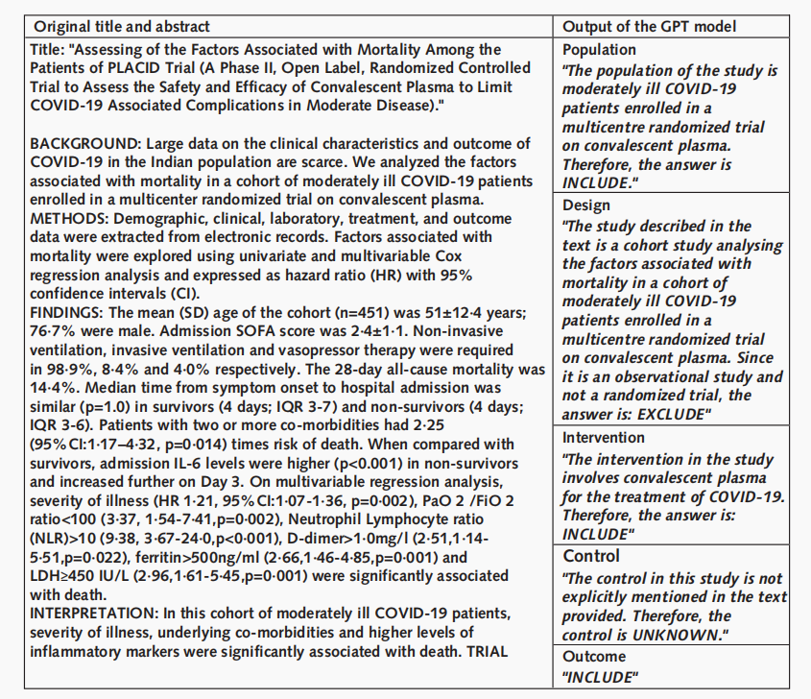
Figure 1. Example of PICOS’ outputs for a given title and abstract [1].

The rationale behind the PICOS method is to structure the screening task to emulate the human process of systematic review screening. It operates on two main assumptions: (i) human screening primarily focuses on the five key aspects of population, intervention, control, outcomes, and study design, and (ii) a paper should be relevant to the systematic review if it is pertinent in at least two of these aspects. By tackling each aspect individually, PICOS breaks down the complex screening task into simpler, more manageable components, facilitating easier and more accurate evaluations by ChatGPT.
Limitations of existing method. Firstly, it exhibits a high false positive rate, resulting in a substantial number of papers requiring manual review by human screeners. For example, [1] reports that the false positive rate of PICOS could be as high as 45.4%, meaning almost half of the candidate papers necessitate manual screening. This high false positive rate is particularly detrimental when dealing with large volumes of candidate papers, often numbering in the thousands. Secondly, the PICOS method necessitates manual tuning of the prompts for each of the five criteria to better align with the specific requirements of the systematic review being conducted. This manual tuning process requires expertise in prompt engineering, which is not commonly found among medical researchers. Without this prompt tuning, the accuracy of the PICOS method decreases, exacerbating its high false positive rates and also increasing false negative rates.

Furthermore, the accuracy of the PICOS method is heavily reliant on ChatGPT's performance. Our preliminary studies have indicated that ChatGPT often struggles to understand what papers are relevant to a systematic review. For example, in a screening task for a systematic review on the evaluation of Oseltamivir for preventing hospitalization due to Influenza A, ChatGPT excluded a paper titled "Baloxavir Marboxil for Uncomplicated Influenza in Adults and Adolescents," arguing that it focused on Baloxavir Marboxil rather than Oseltamivir for hospitalization prevention. However, the paper was indeed relevant to the systematic review since both Baloxavir Marboxil and Oseltamivir are antiviral medications used to treat influenza. Including studies on Baloxavir Marboxil allows for a direct comparison of the efficacy of both drugs in reducing the severity of Influenza A, contributing to a broader understanding of Oseltamivir's role in preventing hospitalization. This example highlights the challenges and limitations in ChatGPT’s ability to discern nuanced relevance in the context of systematic reviews.

Our plan. To address the deficiency of existing work, we propose to develop a new ChatGPT-based method in screening papers for systematic reviews, utilizing three crucial techniques: chain of thought reasoning, interactive feedback loop, and hierarchical screening.

Chain of Thought Reasoning. Our first objective is to improve ChatGPT's decision-making process by implementing a structured chain of thought framework that emulates human reasoning. This involves developing a multi-step reasoning framework that breaks down the decision-making process into smaller, logical steps for each of the five PICOS criteria: population, intervention, control, outcomes, and study design. We will create detailed prompts to guide ChatGPT through these steps, enabling the model to provide intermediate conclusions for each criterion. Through iterative testing with a set of known papers, we will refine the framework, adjusting the chain of thought process based on feedback and observed performance.

To implement this framework, we will use a diverse dataset of systematic reviews with known outcomes for training and validation. The performance will be measured using metrics such as accuracy, precision, recall, and F1 score, comparing the chain of thought reasoning framework to a baseline single-step decision-making process. We will conduct pilot studies on new systematic reviews to evaluate the practical application of this framework, focusing on its ability to accurately identify relevant papers and reduce false positives and negatives. We will also gather feedback from researchers to assess usability and make further refinements.

Interactive Feedback Loop. The second objective is to develop an interactive feedback loop that allows ChatGPT to query researchers for additional information or clarification when it encounters ambiguities during the screening process. This will involve designing an interactive system where ChatGPT can generate queries to ask researchers for more details in uncertain or ambiguous situations. We will develop a mechanism for researchers to provide responses, which will then be incorporated into ChatGPT's decision-making process. This includes setting up protocols for how the model should update its assessment based on new information.

We will integrate the interactive feedback loop into our ChatGPT screening method, ensuring seamless transitions between automated assessments and human interactions. ChatGPT will be instructed to recognize situations where additional information is needed and to generate appropriate, context-specific queries. The system will be calibrated to handle responses efficiently and update screening decisions accordingly. Case studies involving real systematic reviews will be conducted to evaluate the practical application of the interactive feedback loop. Metrics such as the reduction in ambiguous decisions and improvement in overall screening accuracy will be measured, along with qualitative feedback from researchers on the system's usability and helpfulness.

Hierarchical Screening. Our third objective is to create a hierarchical screening framework that categorizes papers into broad groups before applying detailed screening criteria, thereby streamlining the screening process. This involves developing a two-tiered system where ChatGPT first categorizes papers into broad categories—such as potentially relevant, likely irrelevant, and uncertain—based on a preliminary assessment of titles and abstracts. Detailed screening criteria will then be applied to papers categorized as potentially relevant or uncertain, involving a deeper analysis of the PICOS criteria.

We will create an algorithm that performs the initial broad categorization quickly and efficiently, followed by a detailed evaluation algorithm that applies the full set of PICOS criteria to the categorized papers. This hierarchical framework will be integrated into the existing systematic review workflow, ensuring smooth transitions between broad categorization and detailed evaluation without significant manual intervention. The efficiency of the hierarchical screening framework will be measured by comparing the time saved to a traditional single-step screening process and assessing how much the initial categorization reduces the workload for the detailed evaluation stage.

Accuracy metrics will be used to evaluate both the initial categorization and the detailed evaluation stages, comparing the results with manual screenings to identify discrepancies and areas for improvement. Scalability testing will be conducted on large-scale systematic reviews to assess the framework's robustness and efficiency in handling a high volume of papers while maintaining accuracy and efficiency.

References

[1] Viet-Thi Tran, Gerald Gartlehner, Sally Yaacoub, Isabelle Boutron, Lukas Schwingshackl, Julia Stadelmaier, Isolde Sommer, Farzaneh Alebouyeh, Sivem Afach, Joerg Meerpohl, Philippe Ravaud. Sensitivity and Specificity of Using GPT-3.5 Turbo Models for Title and Abstract Screening in Systematic Reviews and Meta-analyses. Annals of Internal Medicine. 2024.

